PROGRAM-7

1. Input Details
For each product:
- Product Name
- Category
- Unit Price
- Quantity

2. Item Amount Calculation
$$\text{Item Amount}=\text{Unit Price}×\text{Quantity} \\ \text{Subtotal}=\sum{\text{Item Amounts}}$$
3. Category-Specific Taxes
Example tax rates:
Category | Tax Rate
Grocery | 5%
Electronics | 18%
Clothing | 12%
Stationery | 8%
Tax Calculation
$$\text{Tax}=\text{Item Amount}×\frac{\text{Tax Rate}}{100}$$

4. Threshold Discounts
Example discount rules:
Purchase Amount | Discount
₹5,000 - ₹9,999 | 5%
₹10,000 - ₹19,999 | 10%
Above ₹20,000 | 15%
$$\text{Discount}=\text{Subtotal}×\frac{\text{Discount Rate}}{100}$$

5. Maximum Concession Limit
To prevent excessive discounts:
$$\text{Maximum Discount Allowed}=\text{₹}3,000$$
If calculated discount exceeds ₹3,000:
$$\text{Discount}=\text{₹}3,000$$

6. Final Bill Calculation
$$\text{Total Tax}=\sum{\text{Product Taxes}} \\ \text{Net Amount}=\text{Subtotal}+\text{Total Tax}-\text{Discount}$$

7. Algorithm
- Input product details.
- Calculate item amount for each product.
- Compute tax according to product category.
- Calculate subtotal.
- Apply threshold discount.
- Check maximum concession limit.
- Calculate final payable amount.
- Generate itemized invoice.
- Display bill summary.

Example
Products Purchased
Product | Category | Price | Qty | Amount
Rice | Grocery | ₹100 | 20 | ₹2,000
Shirt | Clothing | ₹800 | 5 | ₹4,000
Headphones | Electronics | ₹2,500 | 2 | ₹5,000
Subtotal
$$\text{₹}2,000+\text{₹}4,000+\text{₹}5,000=\text{₹}11,000$$
Tax
- Grocery Tax = ₹100
- Clothing Tax = ₹480
- Electronics Tax = ₹900
Total Tax
$$\text{₹}100+\text{₹}480+\text{₹}900=\text{₹}1,480$$
Discount
- Purchase Amount = ₹11,000
- Eligible Discount = 10%
$$\text{₹}11,000×10\%=\text{₹}1,100$$
Since ₹1,100 is below the maximum concession limit, it is applied fully.
Final Bill
$$\text{₹}11,000+\text{₹}1,480-\text{₹}1,100=\text{₹}11,380$$

Itemized Invoice
Plain Text
----------------------------------------
RETAIL INVOICE
----------------------------------------
Product Qty Amount
Rice 20 ₹2,000
Shirt 5 ₹4,000
Headphones 2 ₹5,000
----------------------------------------
Subtotal ₹11,000
Total Tax ₹ 1,480
Discount ₹ 1,100
----------------------------------------
Net Amount ₹11,380
PROGRAM-8

1. Input Details
- Raw Material Cost
- Labor Charges
- Wastage Percentage
- Machine Operating Cost
- Number of Units Produced
- Selling Price per Unit
- Target Profit Percentage
- 2. Material Cost Calculation
- $\text{Material Cost}=\text{Raw Material Cost}$
- Wastage Cost
- $\text{Wastage Cost}=\text{Material Cost}×\frac{\text{Wastage \%}}{100}$
- 3. Total Manufacturing Cost
- $\text{Total Cost}=\text{Material Cost}+\text{Labor Charges}+\text{Machine Cost}+\text{Wastage Cost}$

- 4. Revenue Calculation
- $\text{Revenue}=\text{Units Produced}×\text{Selling Price per Unit}$
5. Profit Calculation
$$\text{Profit}=\text{Revenue}-\text{Total Cost}$$
Profit Percentage
$$\text{Profit \%}=\frac{\text{Profit}}{\text{Total Cost}}×100$$

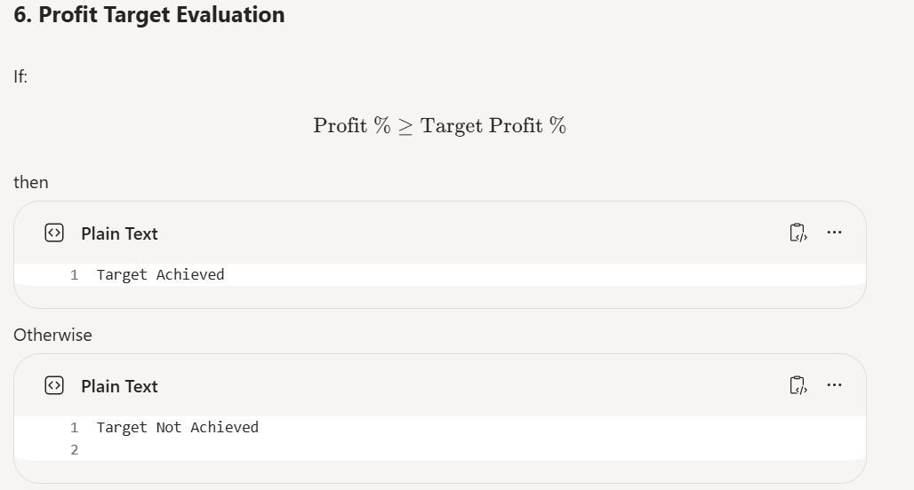

7. Expected Outcome
The project will provide an automated retail billing solution that calculates product totals, applies category-specific taxes and discount rules, enforces concession limits, and generates a clear and accurate invoice for customers.

